Wesley Walker

4/11/2022

CTEC 415

Professor Wilson

Study Guide

1. Wide Area Network- A vast network of information that is not restricted to a particular area. Through a WAN provider, WANs may permit communication, information exchange, and much more between devices all over the world.

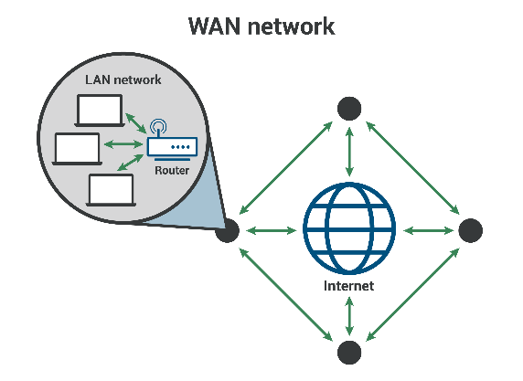

2. Host- A computer or other device linked to a computer network can also operate as a server, providing information resources, services, and applications to network users or other hosts.

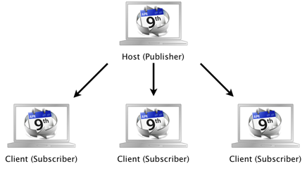

3. End systems- A device that is directly connected to the Internet, resulting in the creation of an interface that individual users may access.

4. Bandwidth- a range of frequencies within a specific band utilized for signal transmission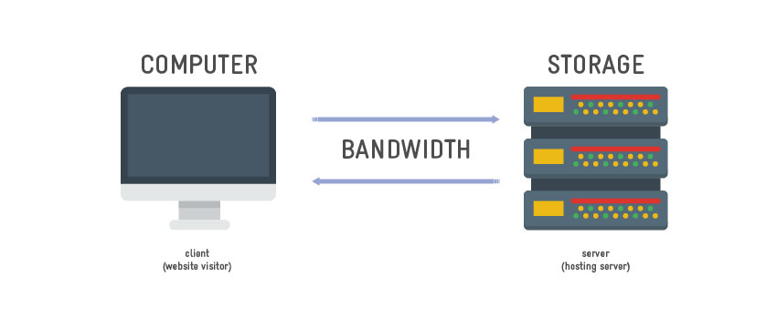

5. Bit rate- the number of bits used per second to represent a continuous medium such as audio or video after source coding

6. Latency- a time delay between the cause and the effect of some physical change in the system being observed.

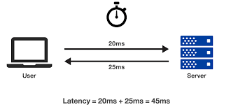

7. Network Redundancy- A duplicated infrastructure in which extra or alternate instances of network devices and connections are established to provide an alternate path in the event of a primary service failure.

8. URL- a unique identifier used to locate a resource on the internet.

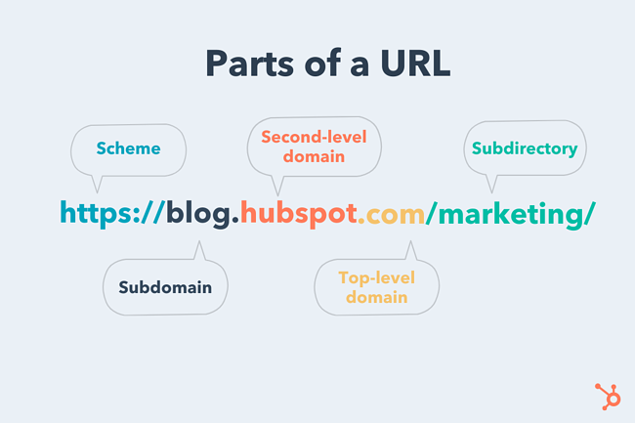

9. Communication links- a connection between a hyperlink or graphical element and one or more such items in the same or different electronic document

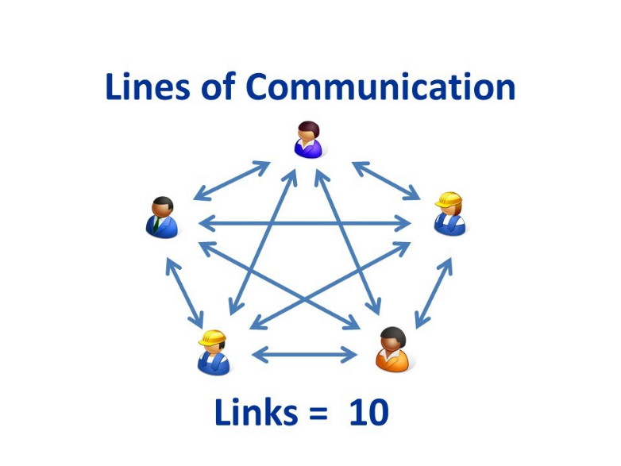

10. Net Neutrality- the principle that Internet service providers must treat all Internet communications similarly and not charge different prices to users based on content, website, platform, application, kind of equipment, and so on.

21. Servers- a piece of computer hardware or software that provides functionality for other programs or devices.

22. Digital subscriber Line- a technology that transports high-bandwidth data over a simple telephone line that is directly connected to a modem.

23. Internet Service Providers- an organization that provides services for accessing, using, or participating on the Internet.

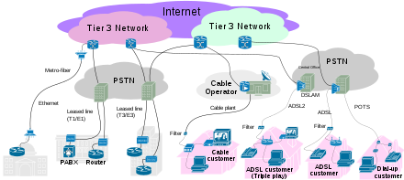

24. Protocols- an established set of rules that determine how data is transmitted between different devices in the same network.

25. Wireless network- a computer network that uses wireless data connections between network nodes.

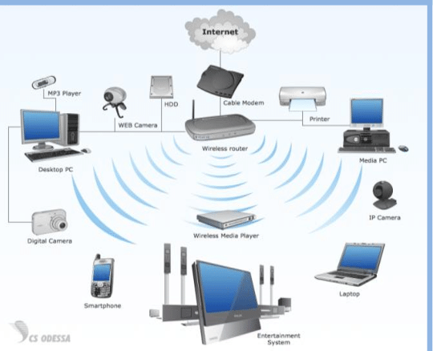

26. Utility program- software designed to help analyze, configure, optimize or maintain a computer.

27. Telecommunications- the transmission of information by various types of technologies over wire, radio, optical, or other electromagnetic systems.

28. Network architecture- a network's structural and logical layout. It describes how the network devices are connected and the rules that govern data transfer between them.

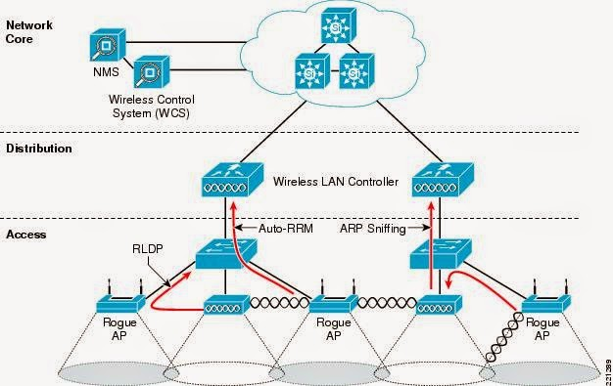

29. Local Area Network- a group of computers and peripheral devices that share a common communications line or wireless link to a server within a distinct geographic area.

30. Digital subscriber line access multiplexer- a network device that connects multiple customer digital subscriber line interfaces to a high-speed digital communications channel using multiplexing techniques.